Athletics Events Held on Temporary Facilities
Survey Form 2020
(To be sent together with the Application Form)

GENERAL
This is generally completed by the company conducting the survey. The following key items must be provided:
- identification of the surveyor
- identification of the facility and event sites surveyed, including a plan showing field event layouts
- facility measurements on diagram provided – to note that:
  - distances longer than 20m are to be measured by electro optical instruments
  - angles are to be measured by theodolite
- details on the measurement instrument used including:
  - manufacturer and model
  - serial number
  - current (no older than 12 months) Certificate of Instrument Accuracy (mentioning the instrument serial number) that can be traced back to national and international standards of measurement (issued by an authorised service centre or laboratory)

To be noted that, when a competition is held over more than one day, the survey should be made on the day of the first event. In either case, if the surveyor can be satisfied that there will be no movement or alteration to the facilities being surveyed, the survey may be completed up to two days prior to the day of the first event.

It is not for the surveyor or others to determine whether dispensations might be provided for any non-conformity with the Rules or the stipulations of the Track and Field Facilities Manual. These are matters for World Athletics alone to determine.

All the information required in this form must be determined by the surveyor and he should not rely on any other measurement work that may have been done by others.

SURVEYOR
Company
Name
Address
Telephone
Email
Date of Survey
Weather conditions and temperature
Instrument | Theodolite: |  | No.:
 | Distance Meter: |  | No.:

FACILITY
Name
Address
Event Site(s) surveyed
EVENT SITE – MEASUREMENTS LONG JUMP

Rule Requirement
The runway | The length of the runway is:  minimum 40m, if possible 45m. |  | m
 | It has a width of: 1.22m ± 0.01 |  | m
 | It is marked by white lines 50mm in width. (Rule 29.2) |  | Y N
Inclination | The maximum lateral inclination of the runway is less than 1:100. |  | Y N
 | In the last 40m of the runway, the overall downward inclination in the running direction is less than 1:1000. (Rule 29.3) |  | Y N
Take-off board | The take-off board is in accordance with the Rule.  (Rule 30.4 and 30.7) |  | Y N
 | The distance between the take-off line and the far end of the landing area is at least 10m.  (Rule 30.5) |  | m
 | The distance between the take-off line and the nearer end of the landing area is between 1m and 3m. (Rule 30.6) |  | m
Landing area | The landing area has a total width of:  minimum 2.75m, maximum 3m. (Rule 30.9) |  | m
 | The axis of the runway is in line with the centre line of the landing area. |  | Y N
Runway surface
Product name:
Product manufacturer:
Absolute Thickness: |  | mm
World Athletics Product Certificate Number*:
* The current list of synthetic surfaces with Product Certificates is available under Certification System here: https://www.worldathletics.org/about-iaaf/documents/technical-information

EVENT SITE - SPOT LEVELS

Use the diagram to provide levels at 40m from each take-off board including the level at each take-off board and at the landing area kerb four corners.

It is essential that reduced levels (not grades) be provided on each of the runways.

The sign convention used by World Athletics for inclinations is that an upward inclination in the direction of running is positive.

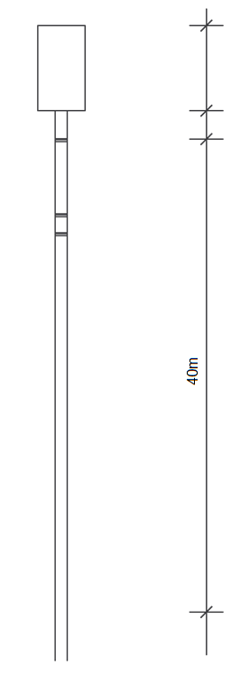

Provide levels at each take-off board (0.000m), 40m from each Long Jump take-off board and at the landing area kerb four corners. If there are multiple horizontal jump runways using a common landing area that must have temporary taping during competition to limit the landing area width to 3.00m maximum, then additional levels shall be provided where the temporary taping will intersect the landing area surround.

SURVEYOR’S CONCLUSIONS

The competition area was checked regarding layout, inclination and dimensional accuracy.

I hereby certify that all measurements and information shown in this report are accurate and are the result of a well-conducted survey.

Considering the attached measurements made during the inspection of the facility, I recommend that the facility be accepted to be in compliance with World Athletics requirements.

YES NO

If the answer is NO please state below the reason(s) why the facility does not comply under World Athletics Rules.

Date:
Surveyor’s Name:
Signature:

